Logging into ECHOES with Credentials

[Echoes - Land Management](https://echoes-platform.eu/app/main/map-view)

4 Steps

Go to <https://echoes-platform.eu/>

1 - Login with Credentials (1/3)

First you will need to enter the username given to you.

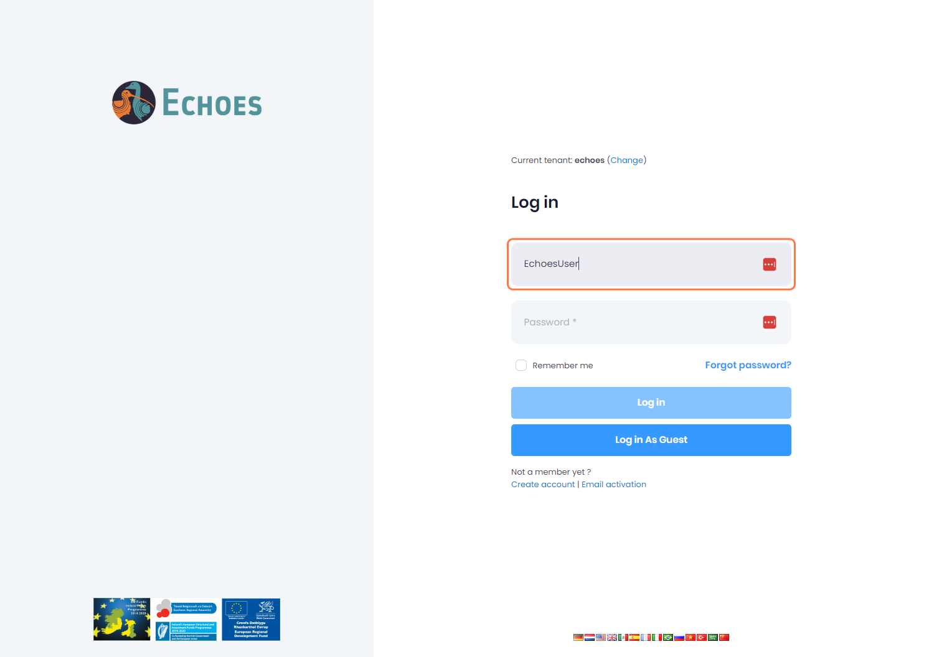

2 - Login with Credentials (2/3)

Next type the password given to you.

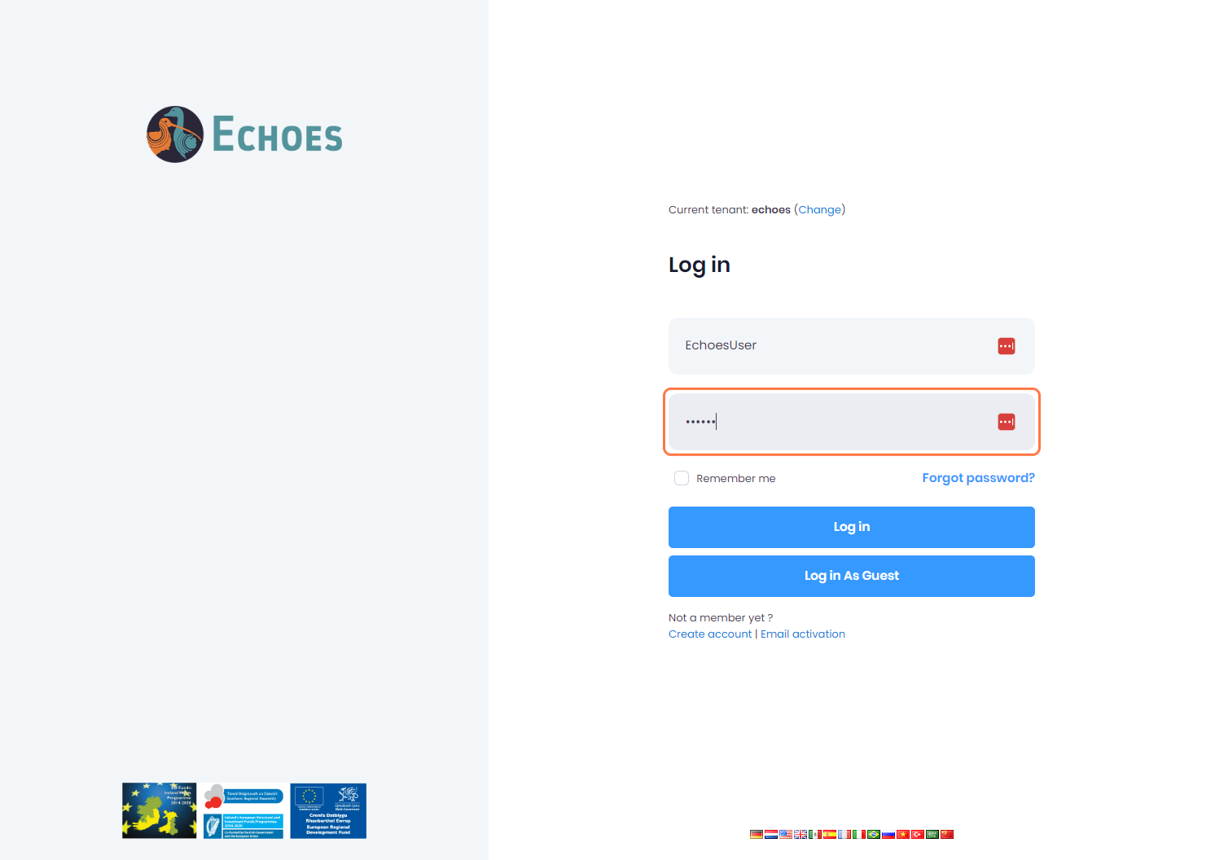

3 - Login with Credentials (3/3)

Finally, click the 'Login in' button

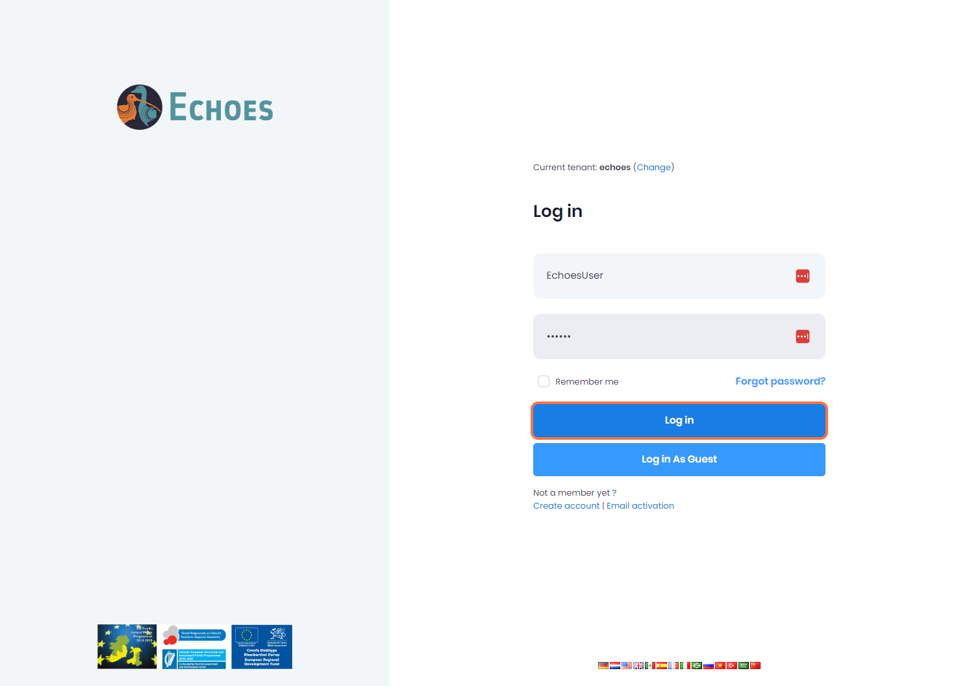

4 - Logged in with credentials sections

You will now see all the sections available to you when logged in with your credentials. **Note**: these sections may vary depending on the permissions you have on your account

